1) Configure 2 slave machines in the Jenkins master.
ARCHITECTURE
- Jenkins Master (EC2)
- Slave 1 → 172.31.18.55
- Slave 2 → 172.31.19.36
- Connection → SSH

STEP 1: Setup Jenkins Master

Run on MASTER EC2:
sudo dnf install java-17-amazon-corretto -y
sudo wget -O /etc/yum.repos.d/jenkins.repo https://pkg.jenkins.io/redhat-stable/jenkins.repo
sudo rpm --import https://pkg.jenkins.io/redhat-stable/jenkins.io-2023.key
sudo dnf install jenkins -y
sudo systemctl enable jenkins
sudo systemctl start jenkins
Open:
http://<MASTER-IP>:8080

STEP 2: Prepare Slave Machines (BOTH)
Run on Slave 1 & Slave 2
sudo dnf install java-17-amazon-corretto -y
Verify:
java -version
No Jenkins install needed ❌
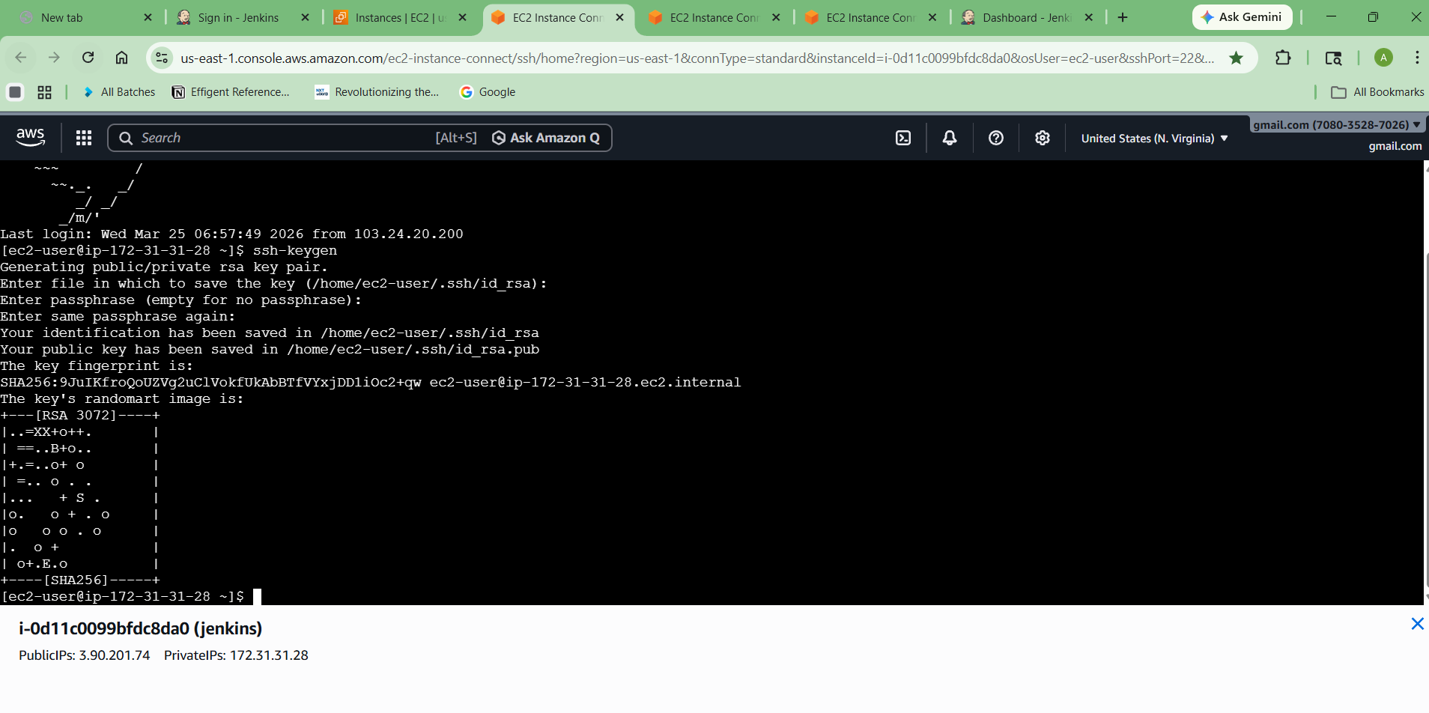
STEP 3: Setup SSH (CRITICAL STEP)
🔹 On MASTER
ssh-keygen
Press Enter 3 times

🔹 Copy public key
cat ~/.ssh/id_rsa.pub
Copy full key

🔹 On SLAVE 1
mkdir -p ~/.ssh
nano ~/.ssh/authorized_keys
Paste key → Save
chmod 700 ~/.ssh
chmod 600 ~/.ssh/authorized_keys

🔹 Repeat for SLAVE 2

TEST (from MASTER only)
ssh ec2-user@172.31.18.55
ssh ec2-user@172.31.19.36
Must login without password ✅

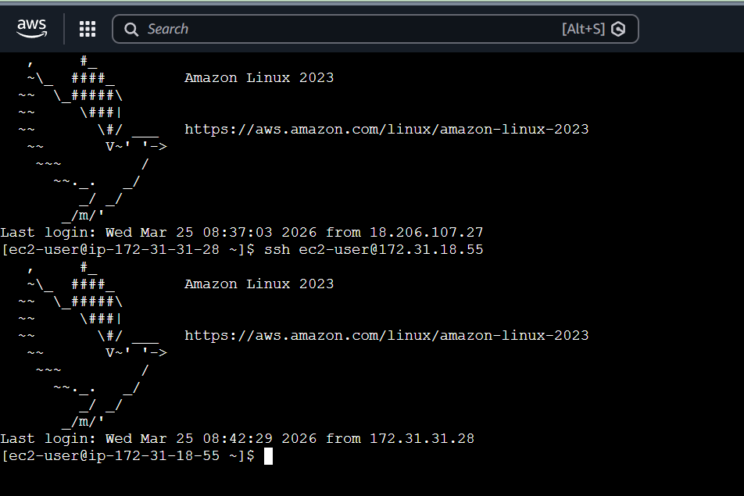
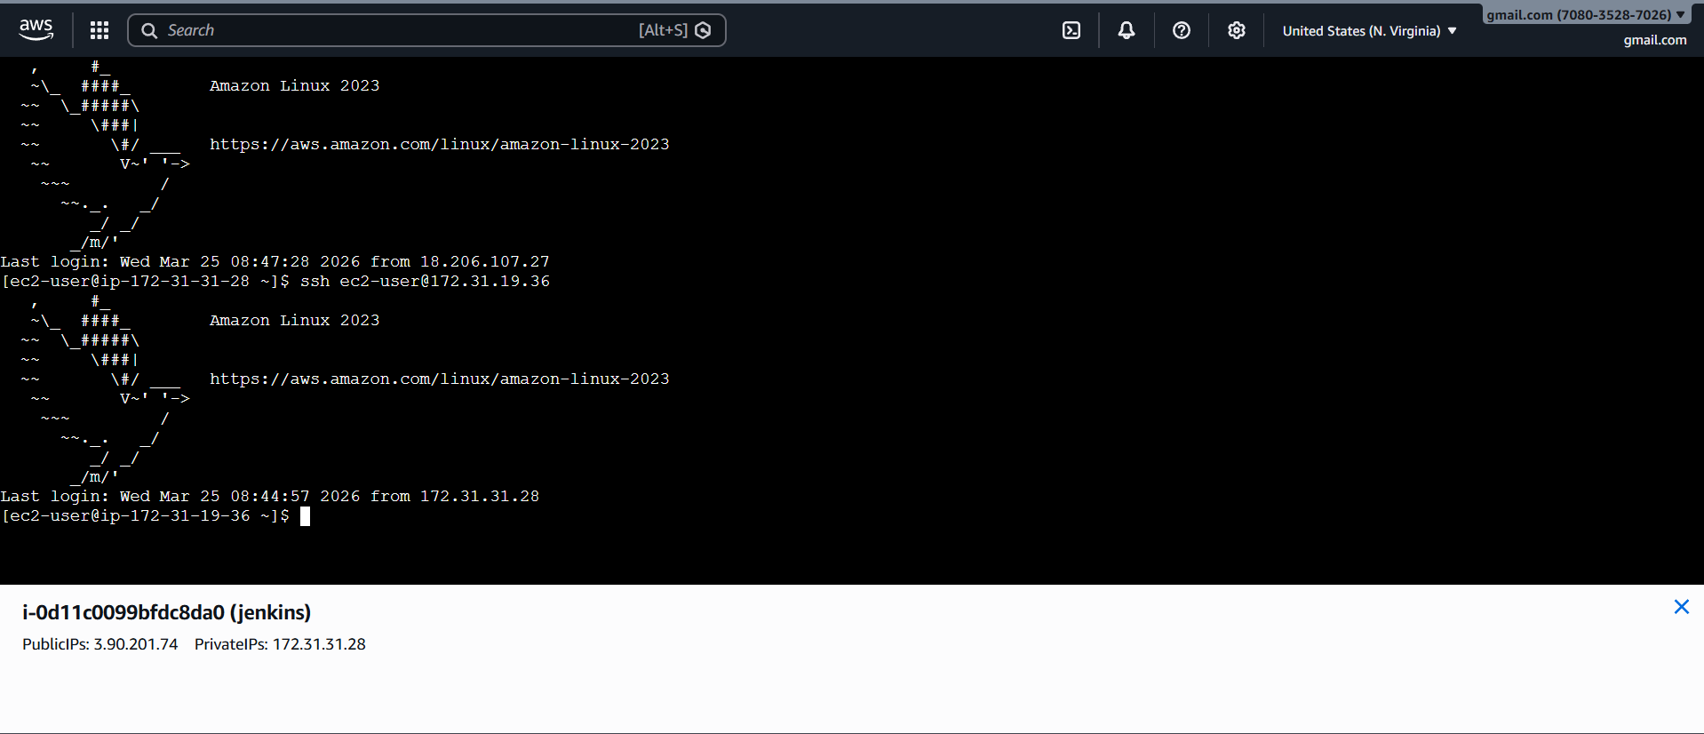
STEP 4: Add Credentials in Jenkins
Go:
Manage Jenkins → Credentials → Global → Add Credentials
Fill:
- Kind: SSH Username with private key
- Username: ec2-user
- Private Key: Enter directly
Paste:
cat ~/.ssh/id_rsa
- ID: ec2-key
Click Add STEP 5: Add Slave 1 Node
Go:
Manage Jenkins → Nodes → New Node
Fill:
- Name: slave-1
- Type: Permanent Agent

Configuration
- Remote root:
/home/ec2-user
- Label:
slave1
- Usage:
Use this node as much as possible
- Launch method:
Launch agents via SSH
- Host:
172.31.18.55
- Credentials:
ec2-key
- Host Key Verification:
Non verifying
Save

▶ Launch Agent
Click:
slave-1 → Launch agent
Status:
Online ✅

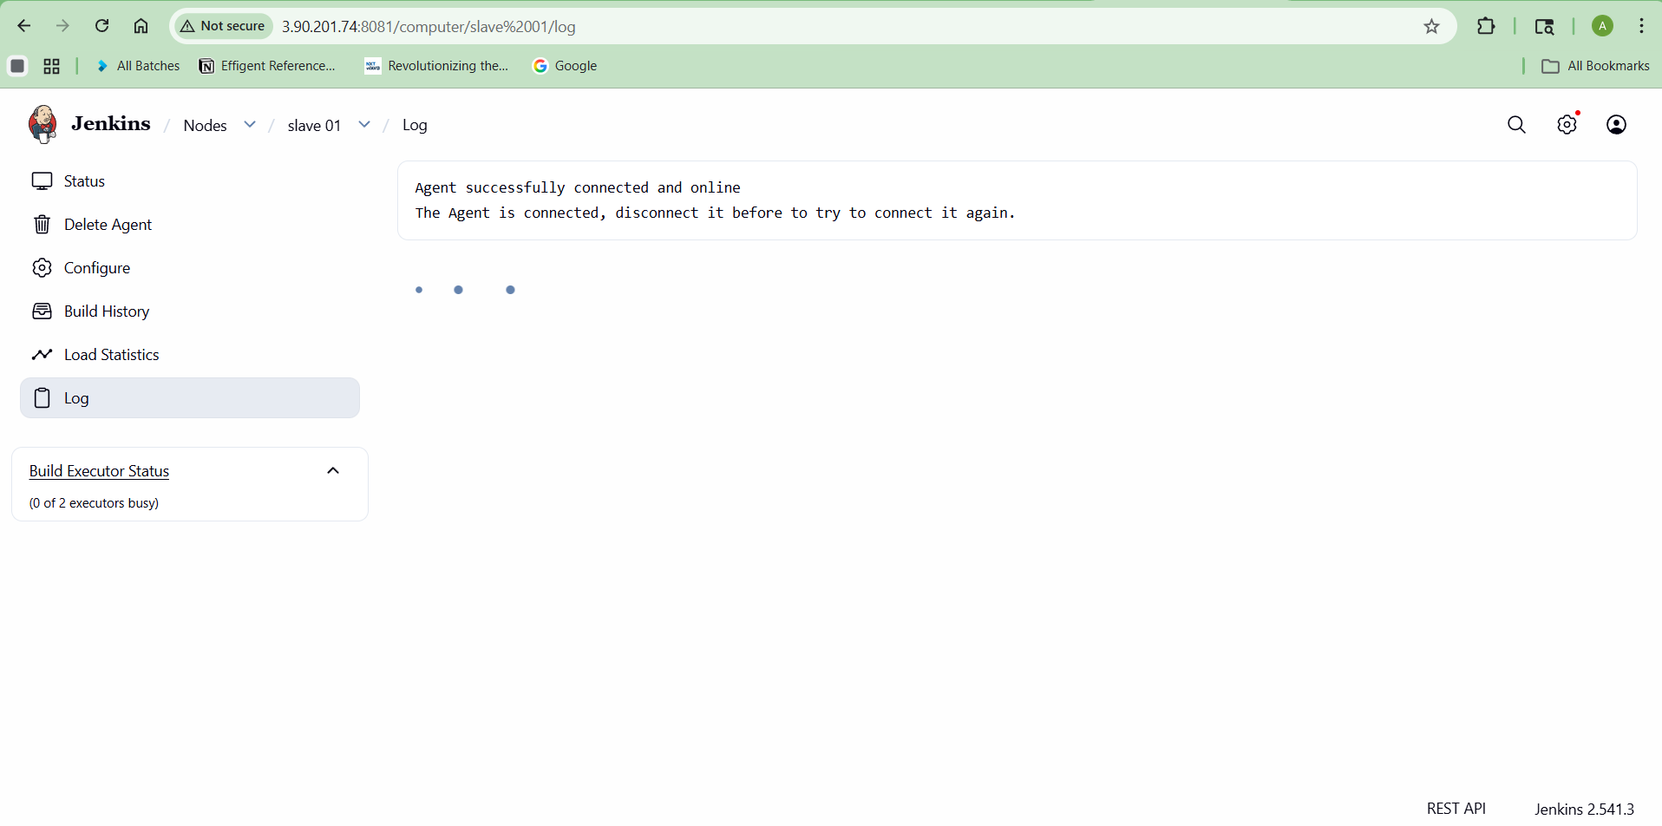
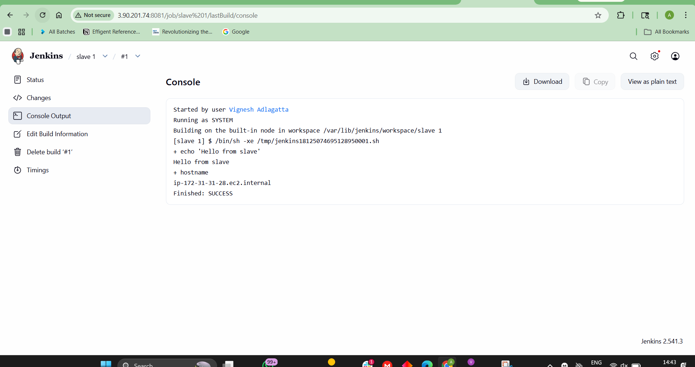
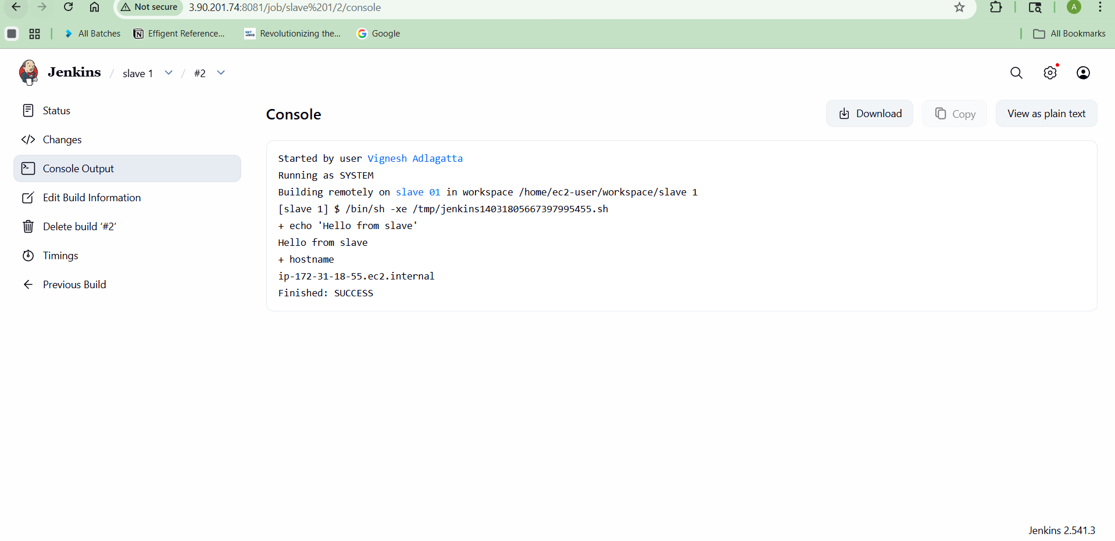
PERFECT SUCCESS
Building remotely on slave 01 ✅
hostname → ip-172-31-18-55.ec2.internal ✅
Finished: SUCCESS ✅

This means:
✔ Job is running on SLAVE (not master)
✔ SSH connection working perfectly
✔ Label configuration fixed
✔ Distributed Jenkins setup DONE 💯

STEP 6: Add Slave 2 Node
Repeat same steps:
- Name: slave-2
- Label: slave2
- Host: 172.31.19.36
Save → Launch → Online ✅

STEP 7: Verify Nodes
Go:
Manage Jenkins → Nodes
You should see:
Node | Status
slave-1 | 🟢 Online
slave-2 | 🟢 Online

STEP 8: Test Job on Slave
Create job:
New Item → Freestyle Project

Configure:
✔ Restrict:
slave1

Build step:
echo "Running on slave"
hostname

Output:
ip-172-31-18-55 ✅

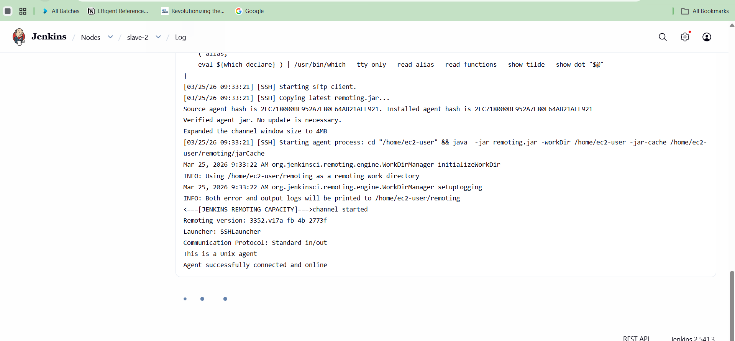

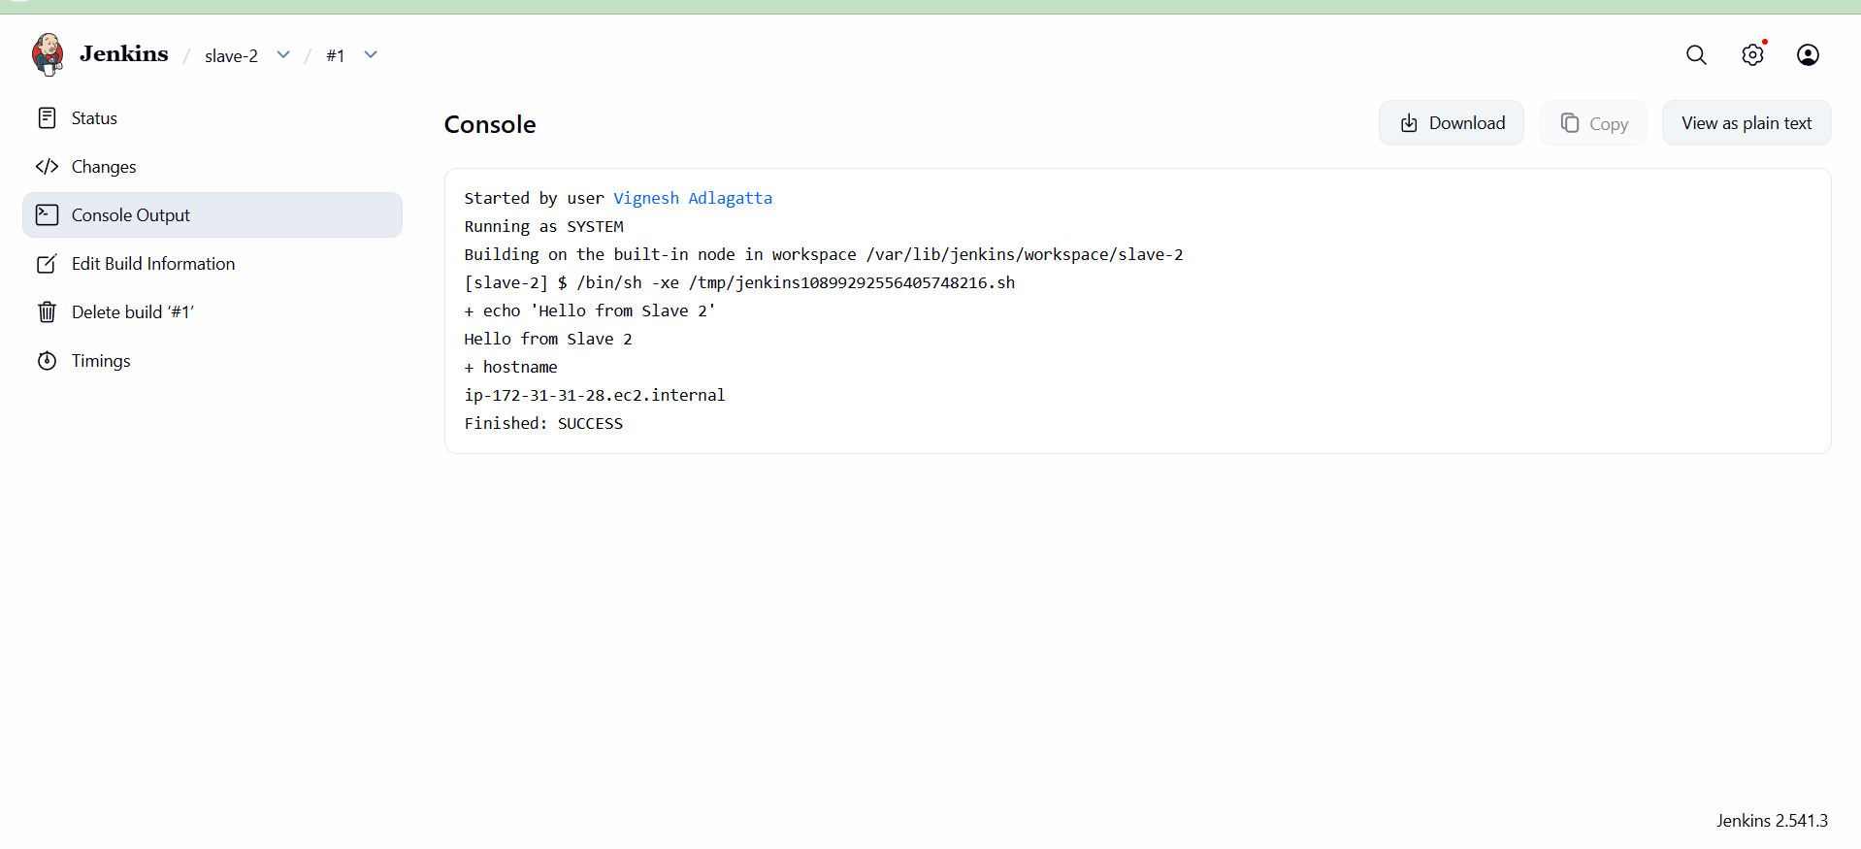

STEP 9: Run on BOTH Slaves (Load Balance)
In job config:
slave1 || slave2
Jenkins picks any available slave

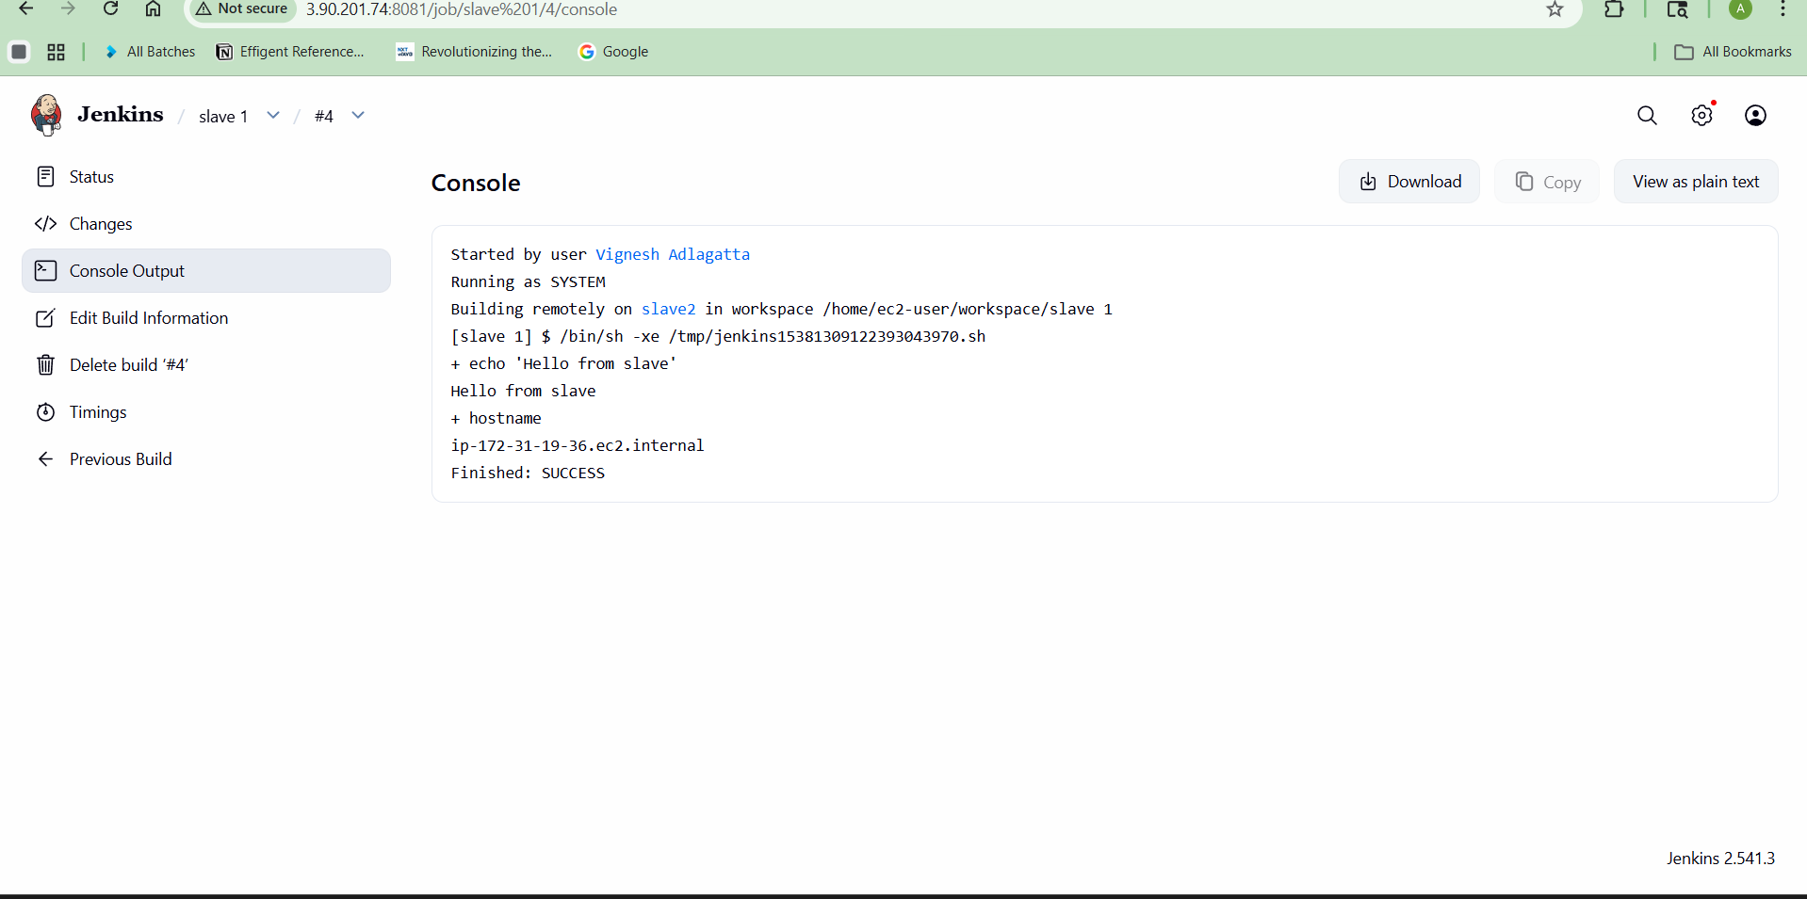
STEP 10: Parallel Execution (ADVANCED)
Create Pipeline Job
Go to Jenkins Dashboard
Click:
New Item

Enter Name:
parallel-job

Select:
Pipeline
Click OK
STEP 2: Add Pipeline Code
Scroll down to:
Pipeline section
🔹 Definition:
Pipeline script

🔹 Script box → Paste your code:
pipeline {
agent none
stages {
stage('Parallel Run') {
parallel {
stage('Slave1') {
agent { label 'slave1' }
steps {
sh 'hostname'
}
}
stage('Slave2') {
agent { label 'slave2' }
steps {
sh 'hostname'
}
}
}
}
}
}

STEP 3: Save
Click:
Save
STEP 4: Run the Pipeline
Click:
Build Now

STEP 5: See Output
Click build → Console Output

✅ Expected Result
You’ll see BOTH running:
[Slave1] ip-172-31-18-55
[Slave2] ip-172-31-19-36

And IMPORTANT:
- Both run at SAME TIME (parallel)

Visual Confirmation
Go to:
Stage View
You’ll see:
Stage | Status
Slave1 | ✅
Slave2 | ✅
Running side-by-side

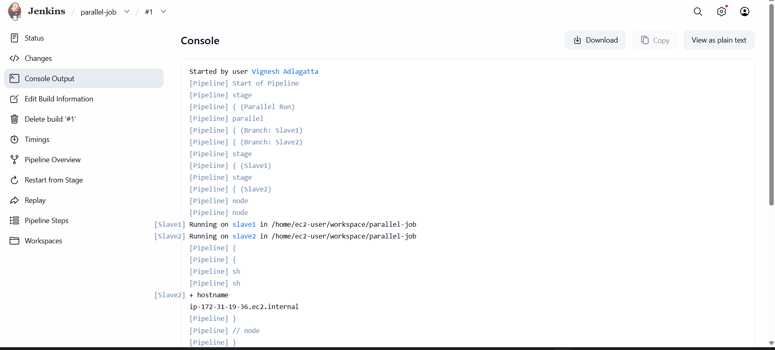
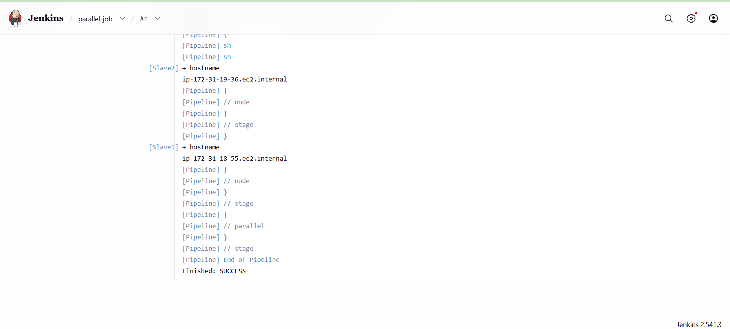

2 Configure Webhooks to the Jenkins job. (GitHub)
GitHub → Repo → Settings → Webhooks
Payload URL:
http://<EC2-IP>:8080/github-webhook/
✔ Content type: application/json
✔ Event: Push
In Jenkins:
✔ GitHub hook trigger for GITScm polling

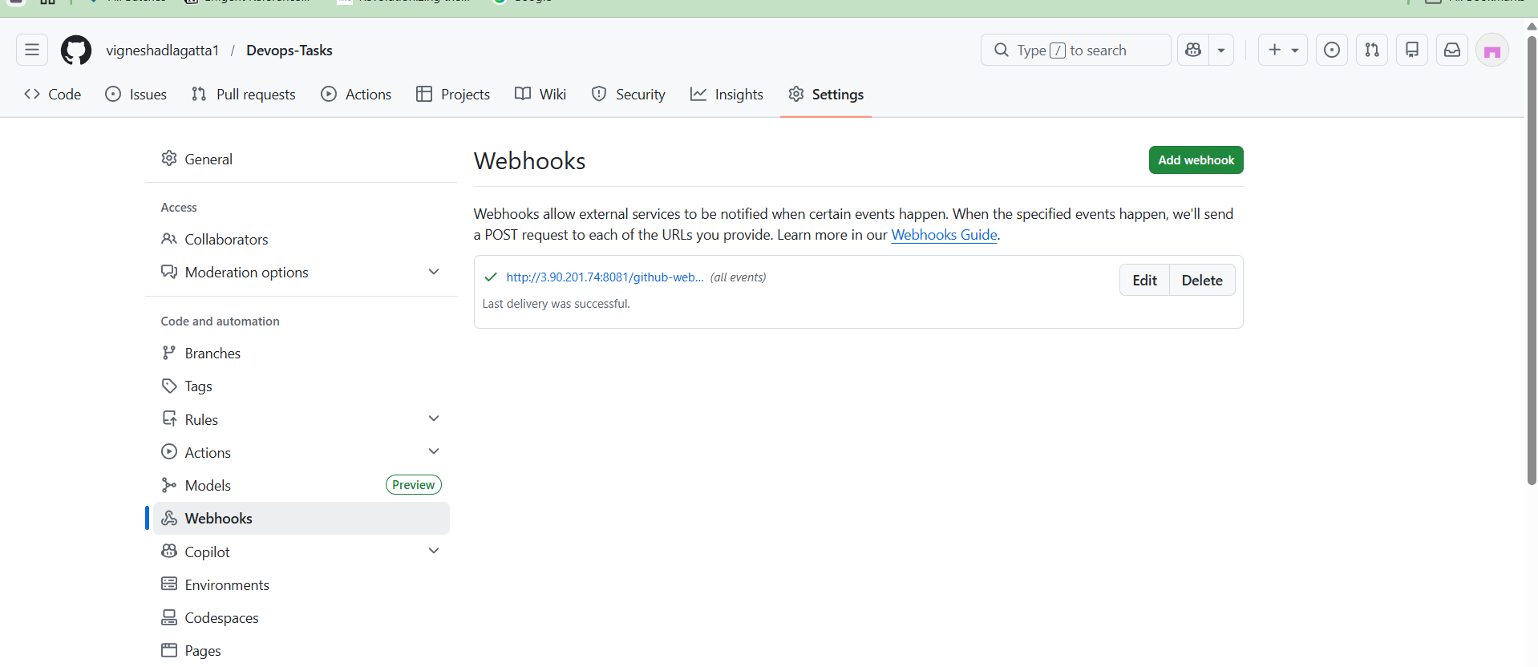
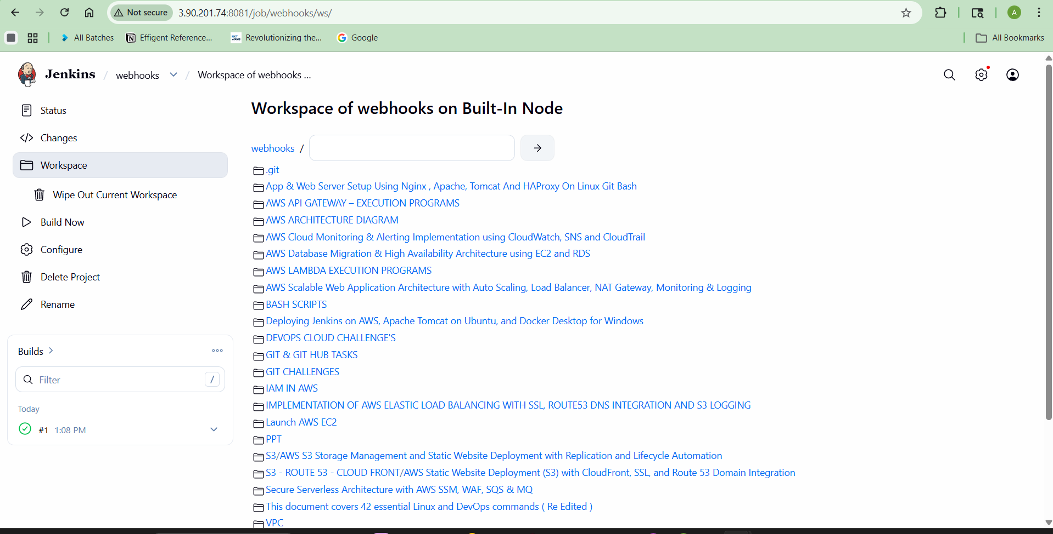

3)Configure Poll SCM and Build Periodically options in the Jenkins job.
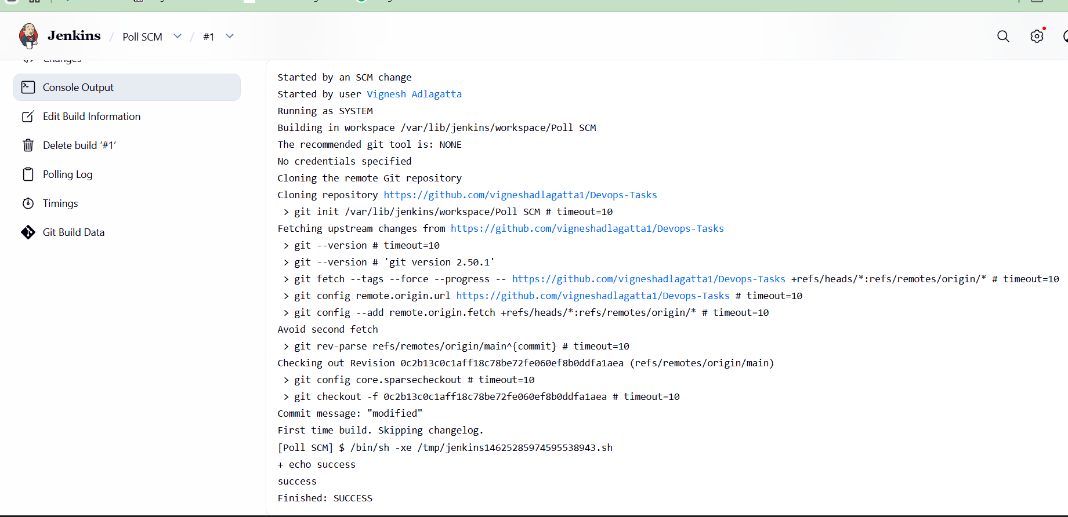

Build Periodically

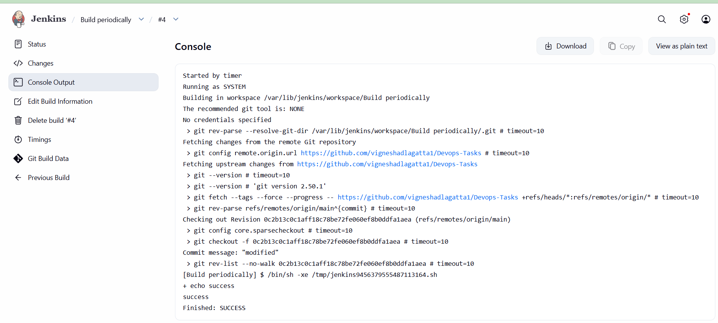
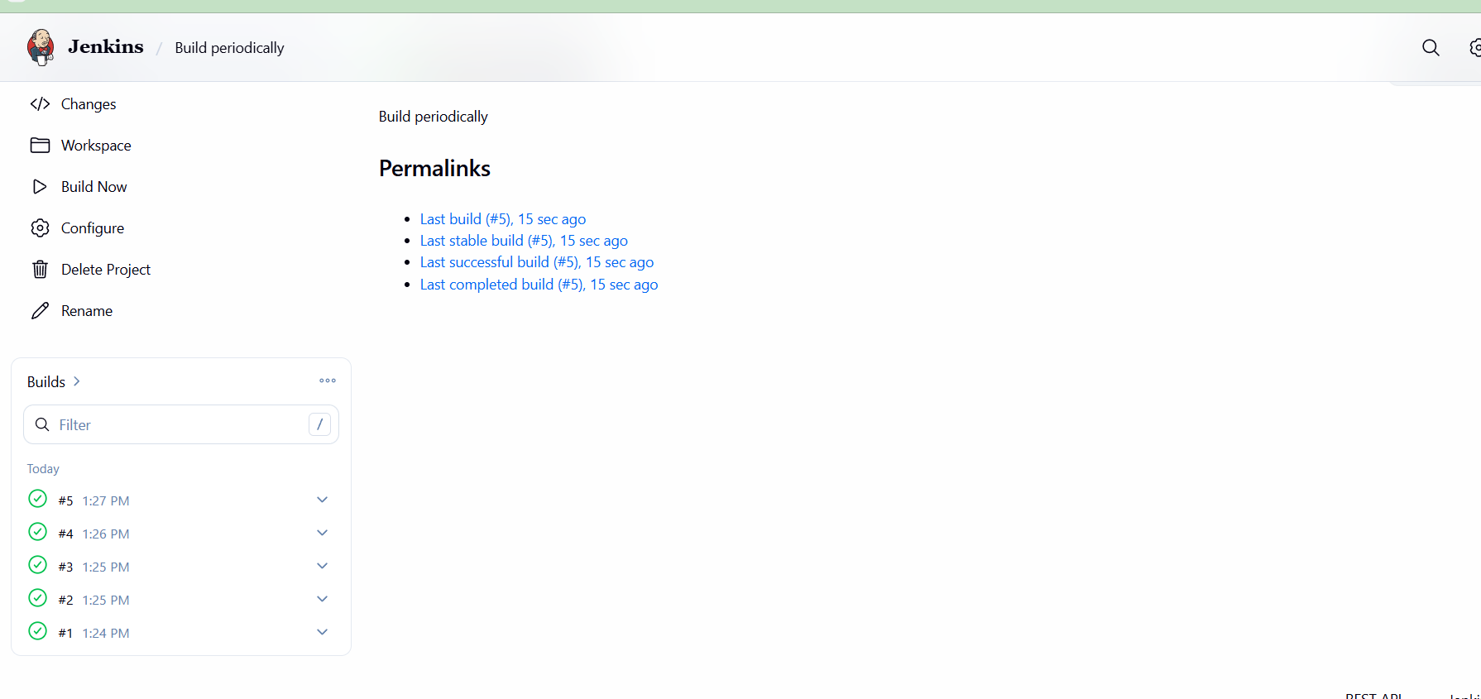

Take a backup of the Jenkins server using a bash-script.
🔹 Step 1: Create Backup Folder with Proper Permission
sudo mkdir -p /opt/jenkins-backup
sudo chown -R ec2-user:ec2-user /opt/jenkins-backup

🔹 Step 2: Run Script with sudo (IMPORTANT)
Instead of:
./jenkins_backup.sh
Run:
sudo ./jenkins_backup.sh

Update your script like this
#!/bin/bash
JENKINS_HOME="/var/lib/jenkins"
BACKUP_DIR="/opt/jenkins-backup"
DATE=$(date +%F-%H-%M)
# Create backup directory
sudo mkdir -p $BACKUP_DIR
echo "Stopping Jenkins..."
sudo systemctl stop jenkins
echo "Taking backup..."
sudo tar -czvf $BACKUP_DIR/jenkins-backup-$DATE.tar.gz $JENKINS_HOME
echo "Starting Jenkins..."
sudo systemctl start jenkins
echo "Backup completed successfully!"

🔹 Step 3: Run Again
sudo ./jenkins_backup.sh

✅ Expected Output
No errors ❌
You’ll get:
/opt/jenkins-backup/jenkins-backup-2026-03-24-XX-XX.tar.gz
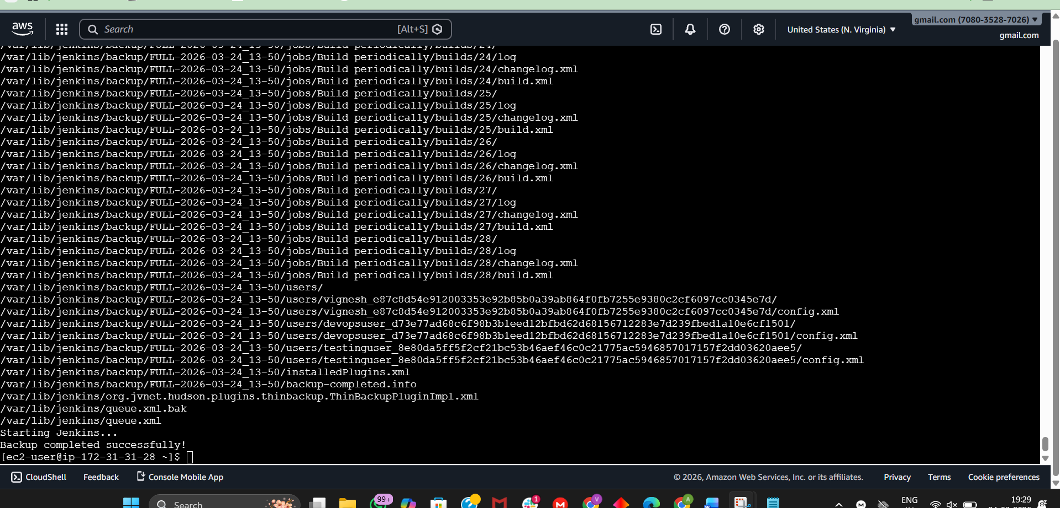
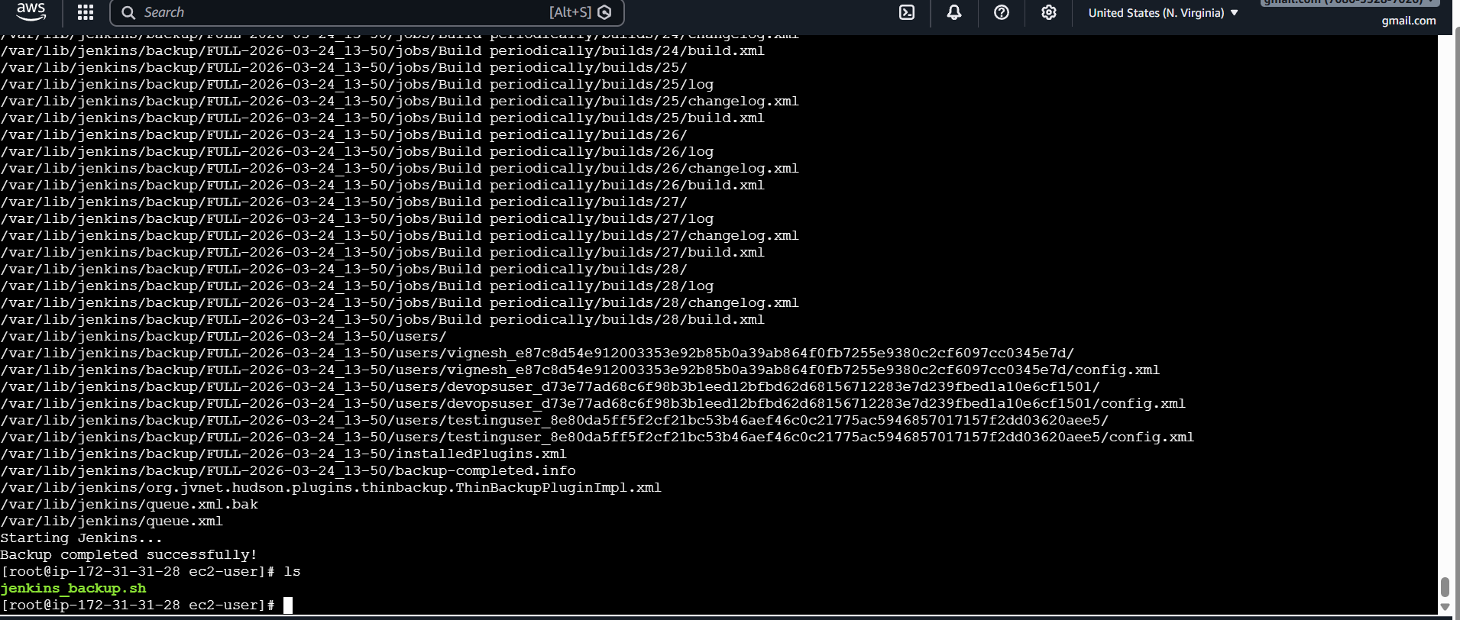
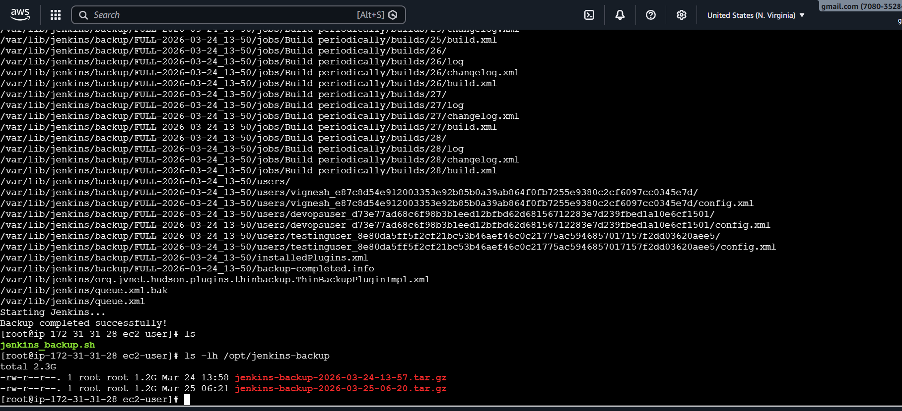

1) Take a backup of Jenkins using the ThinBackup plugin.
- 🔹 Step 1: Create Backup Folder (IMPORTANT)
- Run this on your server:
- sudo mkdir -p /var/lib/jenkins/backup
sudo chown -R jenkins:jenkins /var/lib/jenkins/backup
sudo chmod 755 /var/lib/jenkins/backup

- 🔹 Step 2: Save Configuration
- Now go back to Jenkins UI:
- Click Save

- 🔹 Step 3: Take Backup
- Go to:
- Manage Jenkins → ThinBackup
- Click:
- Backup Now

- 🔹 Step 4: Verify Backup
- Run:
- ls -l /var/lib/jenkins/backup
- You should see something like:
- FULL-2026-03-24_XX-XX

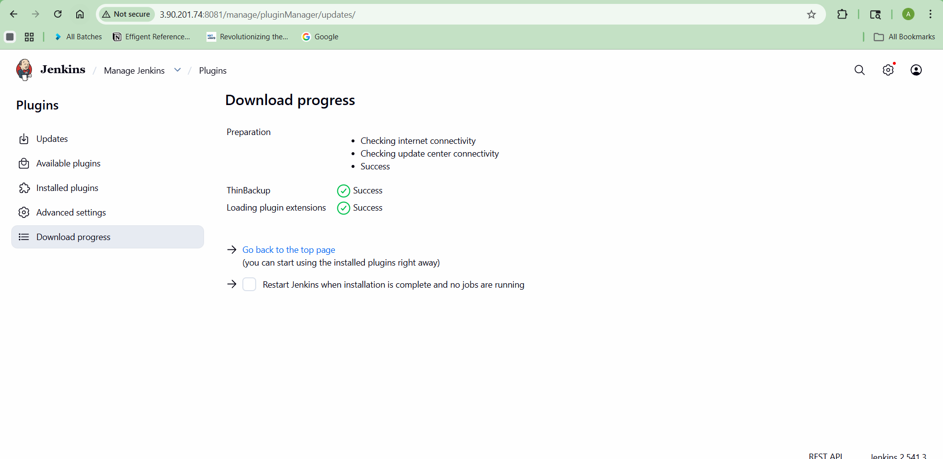
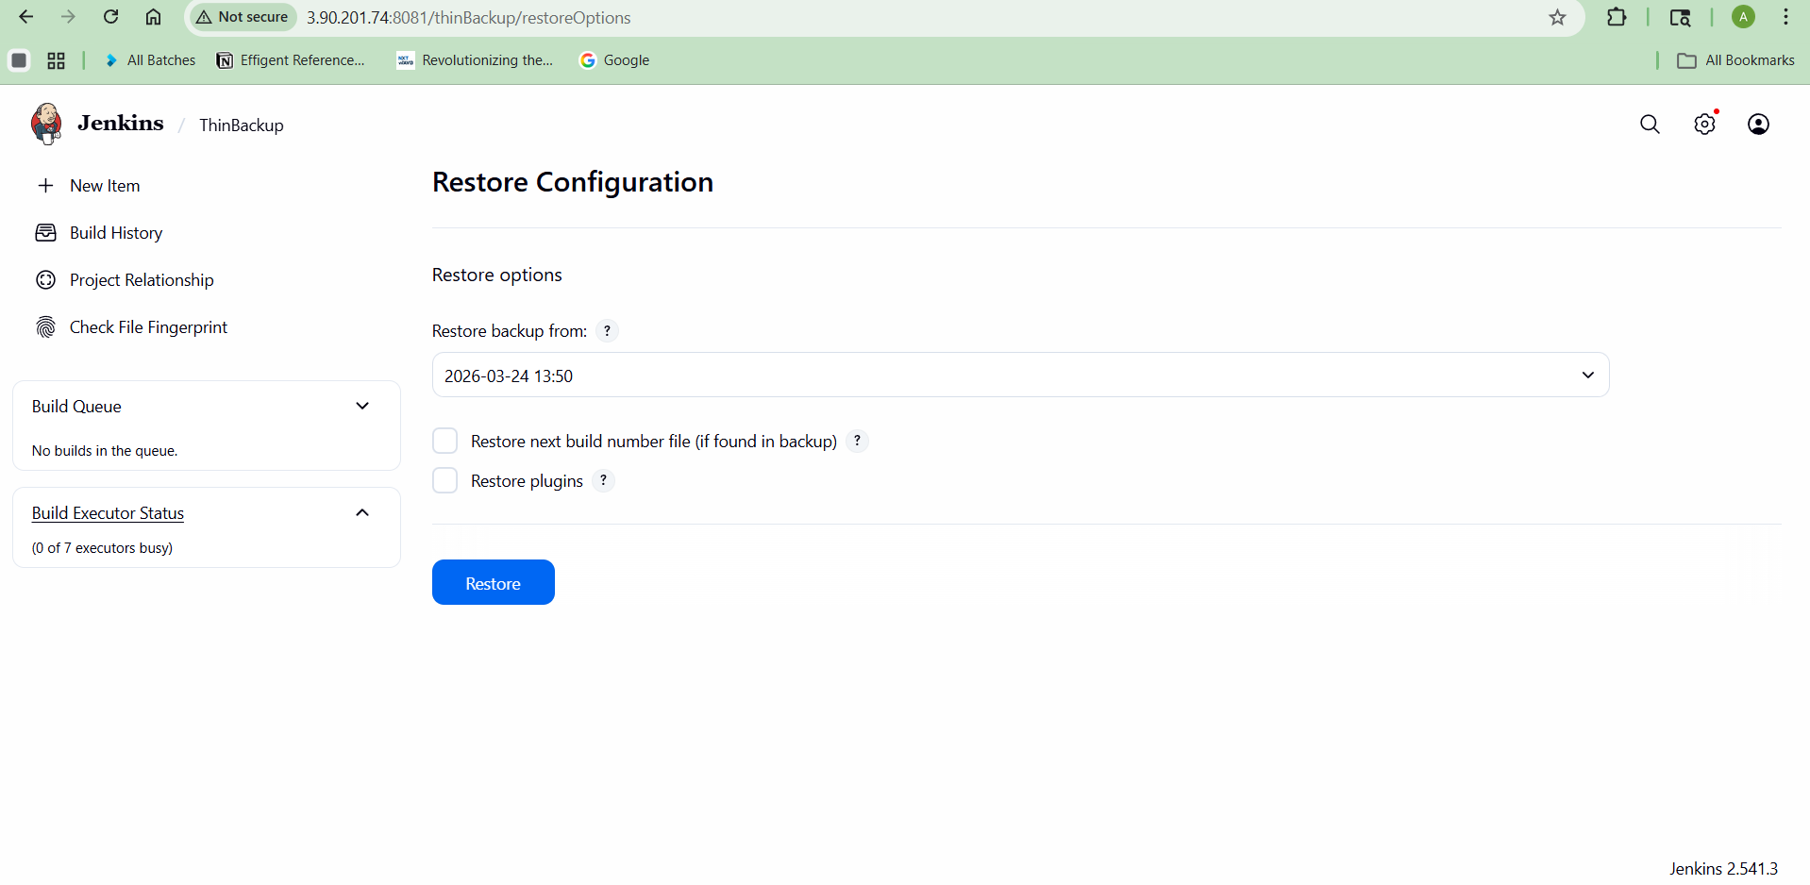
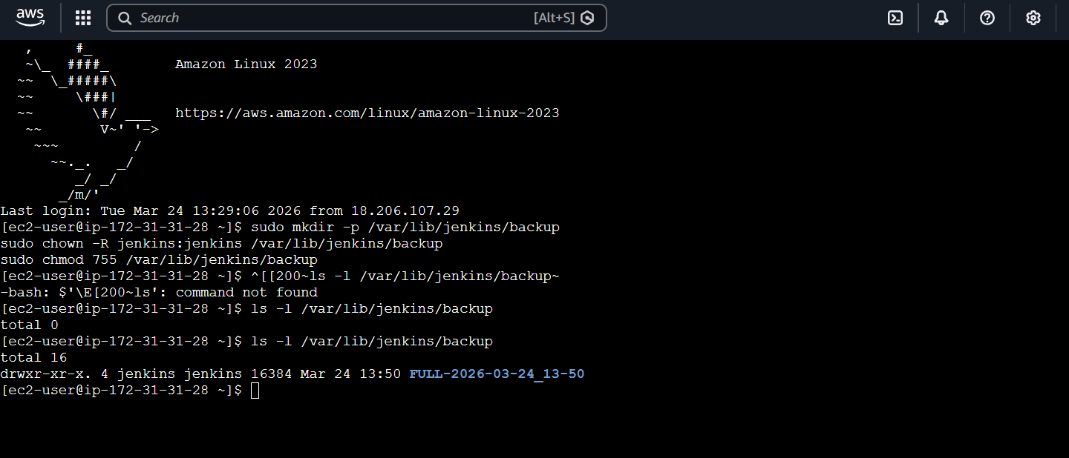

2) Set up a new Jenkins server and restore the backup taken in task 4.
Restore Jenkins Backup on New Server
STEP 1: Launch New Server
Create new VM (AWS EC2 / local / VM)
Minimum:
- OS: Amazon Linux / Ubuntu
- RAM: 2GB+
- Open ports: 8080 (Jenkins)

STEP 2: Install Java (Jenkins dependency)
For Amazon Linux:
sudo dnf install java-17-amazon-corretto -y
Check:
java -version
STEP 3: Install Jenkins
Amazon Linux:
sudo wget -O /etc/yum.repos.d/jenkins.repo https://pkg.jenkins.io/redhat-stable/jenkins.repo
sudo rpm --import https://pkg.jenkins.io/redhat-stable/jenkins.io-2023.key
sudo dnf install jenkins -y
STEP 4: Start Jenkins
sudo systemctl daemon-reexec
sudo systemctl enable jenkins
sudo systemctl start jenkins
Check:
sudo systemctl status Jenkins
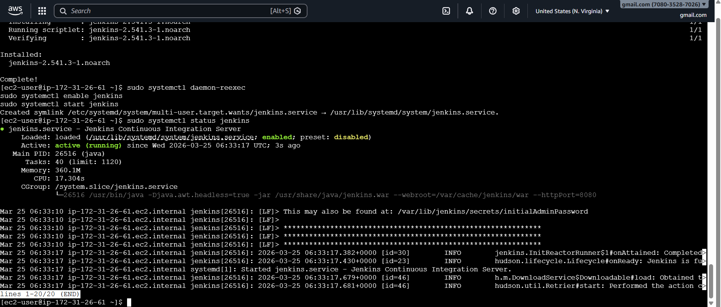

STEP 5: Unlock Jenkins (First Time)
sudo cat /var/lib/jenkins/secrets/initialAdminPassword
Open browser:
http://<your-server-ip>:8080
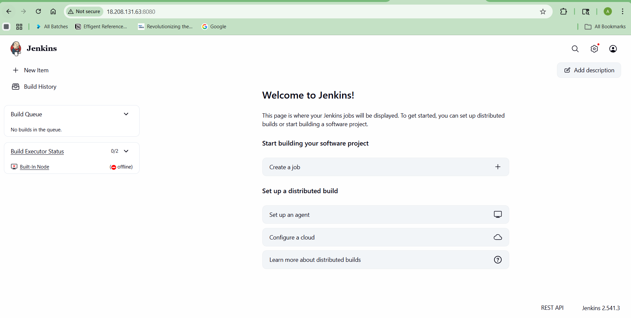

Paste password
Install suggested plugins (temporary step)

Step 1: Start SSH Agent
eval $(ssh-agent)

Step 2: Add your key
ssh-add jenkins.pem
Expected output:
Identity added: jenkins.pem

Step 3: Now connect WITH agent forwarding
ssh -A ec2-user@3.90.201.74

If still fails (backup safe command)
Use both agent + key:
ssh -A -i jenkins.pem ec2-user@3.90.201.74
This ALWAYS works

After login (inside OLD EC2)
Run:
scp /opt/jenkins-backup/jenkins-backup-2026-03-25-06-20.tar.gz ec2-user@18.208.131.63:/home/ec2-user/
IMPORTANT CHECK (don’t skip)
Make sure NEW EC2 allows OLD EC2:
Security Group of NEW EC2:
SSH (22)
Source: 3.90.201.74/32

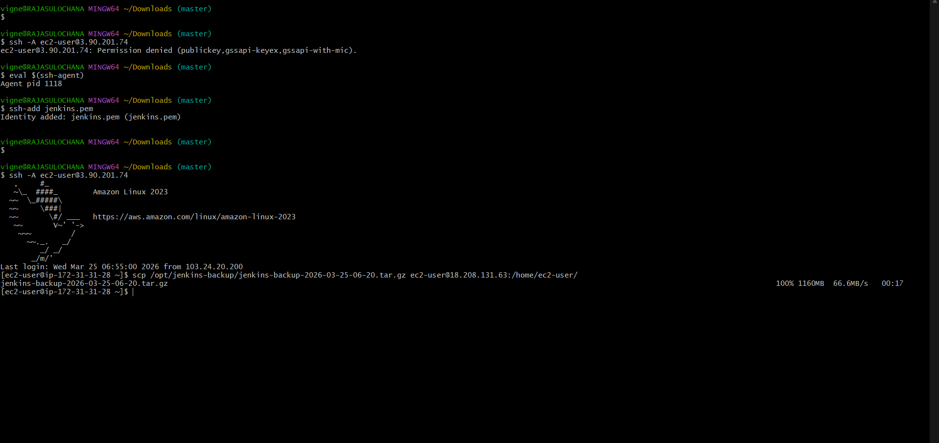

That line right there:
100% 1160MB 66.6MB/s 00:17
means your EC2 ➝ EC2 transfer SUCCESSFULLY completed
What you just achieved
✅ SSH agent forwarding setup
✅ Key handled securely (no copying .pem)
✅ Direct EC2 → EC2 transfer
✅ Real DevOps-level execution

NOW FINAL STEP: RESTORE JENKINS
Let’s finish the mission.

STEP 1: Login to NEW EC2
From your laptop:
ssh -i jenkins.pem ec2-user@18.208.131.63

STEP 2: Verify file
ls /home/ec2-user
You should see:
jenkins-backup-2026-03-25-06-20.tar.gz

STEP 3: Extract backup
tar -xvzf jenkins-backup-2026-03-25-06-20.tar.gz

STEP 4: Stop Jenkins
sudo systemctl stop jenkins

STEP 5: Replace Jenkins Home
sudo mv /var/lib/jenkins /var/lib/jenkins-old
sudo cp -r backup/* /var/lib/jenkins/
(if folder name is different, use that)
ls var/lib/
sudo cp -r var/lib/jenkins /var/lib/

STEP 6: Fix permissions
sudo chown -R jenkins:jenkins /var/lib/jenkins
STEP 7: Start Jenkins
sudo systemctl start jenkins

FINAL CHECK
Open in browser:
http://18.208.131.63:8080
Case 1: Jenkins opens normally
DONE — everything restored successfully
Just login with:
your old username & password

Case 2: Login page appears but you forgot password
No problem 😏 fix it:
Reset password (quick method)
sudo vi /var/lib/jenkins/config.xml
Find:
<useSecurity>true</useSecurity>
Change to:
<useSecurity>false</useSecurity>

Then restart:
sudo systemctl restart jenkins
Now open Jenkins:
- It will open without login
- Create new user:
- Manage Jenkins → Security → Create user

- Re-enable security:
- Change back:
- <useSecurity>true</useSecurity>
- Restart again

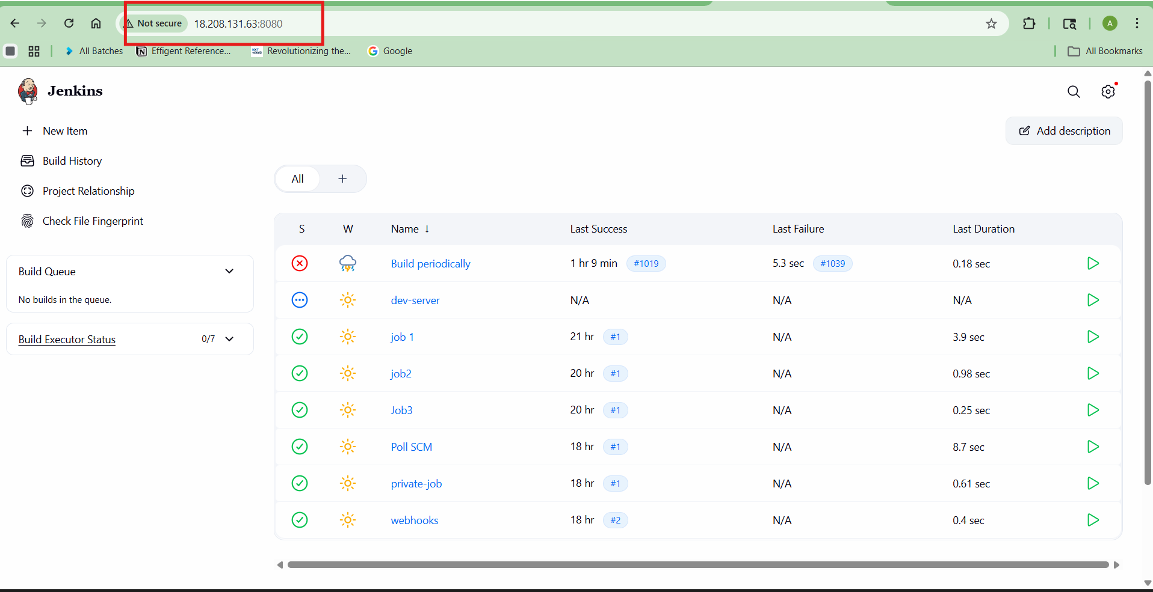

You should see
✅ Old jobs
✅ Build history
✅ Credentials
✅ Plugins

